<div class='tableauPlaceholder' id='viz1699282138712' style='position: relative'><noscript><a href='#'><img alt='statewise agricultural land ' src='https:&#47;&#47;public.tableau.com&#47;static&#47;images&#47;In&#47;Indiasagriculturalcropproductionanalysis_16992665832770&#47;Sheet1&#47;1_rss.png' style='border: none' /></a></noscript><object class='tableauViz' style='display:none;'><param name='host_url' value='https%3A%2F%2Fpublic.tableau.com%2F' /> <param name='embed_code_version' value='3' /> <param name='site_root' value='' /><param name='name' value='Indiasagriculturalcropproductionanalysis_16992665832770&#47;Sheet1' /><param name='tabs' value='no' /><param name='toolbar' value='yes' /><param name='static_image' value='https:&#47;&#47;public.tableau.com&#47;static&#47;images&#47;In&#47;Indiasagriculturalcropproductionanalysis_16992665832770&#47;Sheet1&#47;1.png' /> <param name='animate_transition' value='yes' /><param name='display_static_image' value='yes' /><param name='display_spinner' value='yes' /><param name='display_overlay' value='yes' /><param name='display_count' value='yes' /><param name='language' value='en-US' /><param name='filter' value='publish=yes' /></object></div> <script type='text/javascript'> var divElement = document.getElementById('viz1699282138712'); var vizElement = divElement.getElementsByTagName('object')[0]; vizElement.style.width='100%';vizElement.style.height=(divElement.offsetWidth*0.75)+'px'; var scriptElement = document.createElement('script'); scriptElement.src = 'https://public.tableau.com/javascripts/api/viz_v1.js'; vizElement.parentNode.insertBefore(scriptElement, vizElement); </script>

<https://public.tableau.com/views/Indiasagriculturalcropproductionanalysis_16992665832770/Sheet1?:language=en-US&publish=yes&:display_count=n&:origin=viz_share_link>

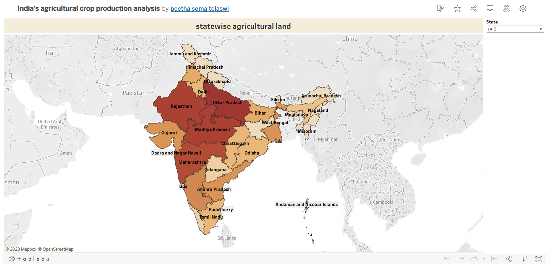

<div class='tableauPlaceholder' id='viz1699282273437' style='position: relative'><noscript><a href='#'><img alt='area vs production ' src='https:&#47;&#47;public.tableau.com&#47;static&#47;images&#47;In&#47;Indiasagriculturalcropproductionanalysis_16992665832770&#47;Sheet2&#47;1_rss.png' style='border: none' /></a></noscript><object class='tableauViz' style='display:none;'><param name='host_url' value='https%3A%2F%2Fpublic.tableau.com%2F' /> <param name='embed_code_version' value='3' /> <param name='site_root' value='' /><param name='name' value='Indiasagriculturalcropproductionanalysis_16992665832770&#47;Sheet2' /><param name='tabs' value='no' /><param name='toolbar' value='yes' /><param name='static_image' value='https:&#47;&#47;public.tableau.com&#47;static&#47;images&#47;In&#47;Indiasagriculturalcropproductionanalysis_16992665832770&#47;Sheet2&#47;1.png' /> <param name='animate_transition' value='yes' /><param name='display_static_image' value='yes' /><param name='display_spinner' value='yes' /><param name='display_overlay' value='yes' /><param name='display_count' value='yes' /><param name='language' value='en-US' /><param name='filter' value='publish=yes' /></object></div> <script type='text/javascript'> var divElement = document.getElementById('viz1699282273437'); var vizElement = divElement.getElementsByTagName('object')[0]; vizElement.style.width='100%';vizElement.style.height=(divElement.offsetWidth*0.75)+'px'; var scriptElement = document.createElement('script'); scriptElement.src = 'https://public.tableau.com/javascripts/api/viz_v1.js'; vizElement.parentNode.insertBefore(scriptElement, vizElement); </script>

<https://public.tableau.com/views/Indiasagriculturalcropproductionanalysis_16992665832770/Sheet2?:language=en-US&publish=yes&:display_count=n&:origin=viz_share_link>

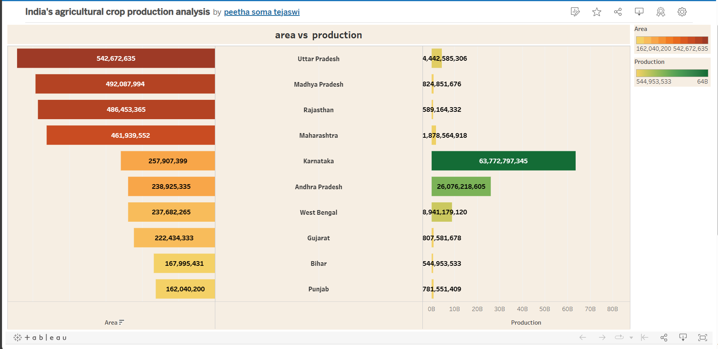

<div class='tableauPlaceholder' id='viz1699282396005' style='position: relative'><noscript><a href='#'><img alt='season based cultivation area ' src='https:&#47;&#47;public.tableau.com&#47;static&#47;images&#47;In&#47;Indiasagriculturalcropproductionanalysis_16992665832770&#47;Sheet3&#47;1_rss.png' style='border: none' /></a></noscript><object class='tableauViz' style='display:none;'><param name='host_url' value='https%3A%2F%2Fpublic.tableau.com%2F' /> <param name='embed_code_version' value='3' /> <param name='site_root' value='' /><param name='name' value='Indiasagriculturalcropproductionanalysis_16992665832770&#47;Sheet3' /><param name='tabs' value='no' /><param name='toolbar' value='yes' /><param name='static_image' value='https:&#47;&#47;public.tableau.com&#47;static&#47;images&#47;In&#47;Indiasagriculturalcropproductionanalysis_16992665832770&#47;Sheet3&#47;1.png' /> <param name='animate_transition' value='yes' /><param name='display_static_image' value='yes' /><param name='display_spinner' value='yes' /><param name='display_overlay' value='yes' /><param name='display_count' value='yes' /><param name='language' value='en-US' /><param name='filter' value='publish=yes' /></object></div> <script type='text/javascript'> var divElement = document.getElementById('viz1699282396005'); var vizElement = divElement.getElementsByTagName('object')[0]; vizElement.style.width='100%';vizElement.style.height=(divElement.offsetWidth*0.75)+'px'; var scriptElement = document.createElement('script'); scriptElement.src = 'https://public.tableau.com/javascripts/api/viz_v1.js'; vizElement.parentNode.insertBefore(scriptElement, vizElement); </script>

<https://public.tableau.com/views/Indiasagriculturalcropproductionanalysis_16992665832770/Sheet3?:language=en-US&publish=yes&:display_count=n&:origin=viz_share_link>

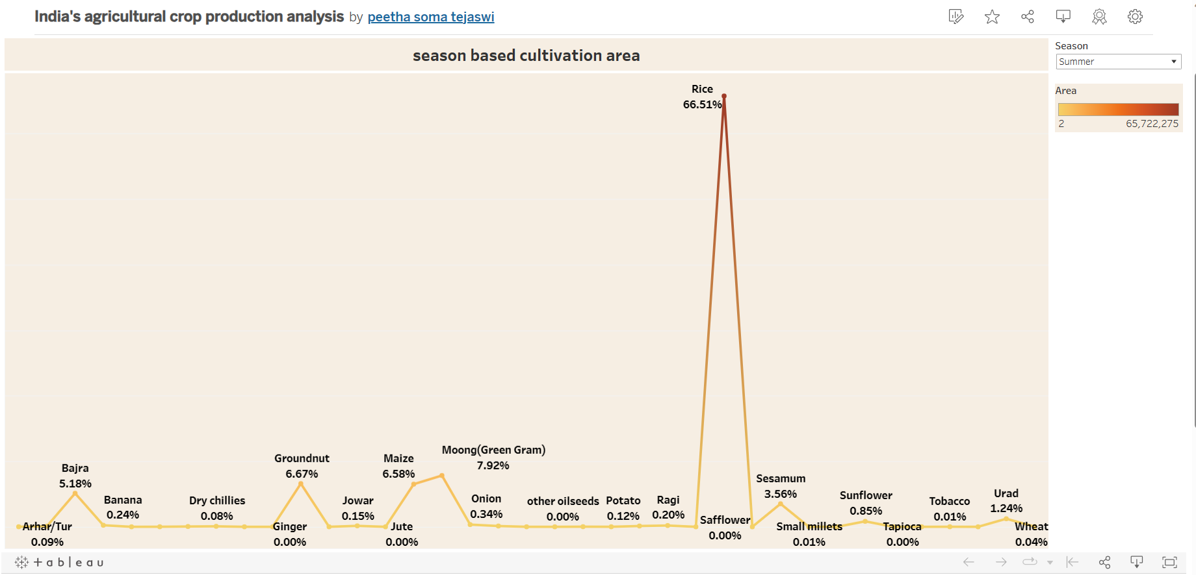

<div class='tableauPlaceholder' id='viz1699282489086' style='position: relative'><noscript><a href='#'><img alt='yield by season ' src='https:&#47;&#47;public.tableau.com&#47;static&#47;images&#47;In&#47;Indiasagriculturalcropproductionanalysis_16992665832770&#47;Sheet4&#47;1_rss.png' style='border: none' /></a></noscript><object class='tableauViz' style='display:none;'><param name='host_url' value='https%3A%2F%2Fpublic.tableau.com%2F' /> <param name='embed_code_version' value='3' /> <param name='site_root' value='' /><param name='name' value='Indiasagriculturalcropproductionanalysis_16992665832770&#47;Sheet4' /><param name='tabs' value='no' /><param name='toolbar' value='yes' /><param name='static_image' value='https:&#47;&#47;public.tableau.com&#47;static&#47;images&#47;In&#47;Indiasagriculturalcropproductionanalysis_16992665832770&#47;Sheet4&#47;1.png' /> <param name='animate_transition' value='yes' /><param name='display_static_image' value='yes' /><param name='display_spinner' value='yes' /><param name='display_overlay' value='yes' /><param name='display_count' value='yes' /><param name='language' value='en-US' /><param name='filter' value='publish=yes' /></object></div> <script type='text/javascript'> var divElement = document.getElementById('viz1699282489086'); var vizElement = divElement.getElementsByTagName('object')[0]; vizElement.style.width='100%';vizElement.style.height=(divElement.offsetWidth*0.75)+'px'; var scriptElement = document.createElement('script'); scriptElement.src = 'https://public.tableau.com/javascripts/api/viz_v1.js'; vizElement.parentNode.insertBefore(scriptElement, vizElement); </script>

<https://public.tableau.com/views/Indiasagriculturalcropproductionanalysis_16992665832770/Sheet4?:language=en-US&publish=yes&:display_count=n&:origin=viz_share_link>

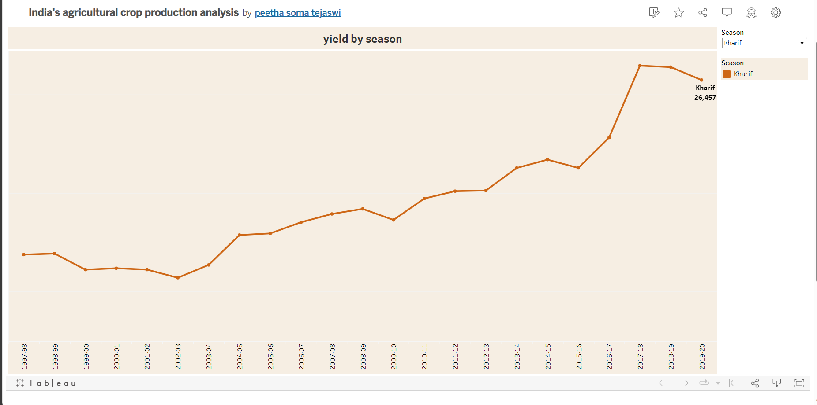

<div class='tableauPlaceholder' id='viz1699282586411' style='position: relative'><noscript><a href='#'><img alt='crop plantation by area ' src='https:&#47;&#47;public.tableau.com&#47;static&#47;images&#47;In&#47;Indiasagriculturalcropproductionanalysis_16992665832770&#47;Sheet5&#47;1_rss.png' style='border: none' /></a></noscript><object class='tableauViz' style='display:none;'><param name='host_url' value='https%3A%2F%2Fpublic.tableau.com%2F' /> <param name='embed_code_version' value='3' /> <param name='site_root' value='' /><param name='name' value='Indiasagriculturalcropproductionanalysis_16992665832770&#47;Sheet5' /><param name='tabs' value='no' /><param name='toolbar' value='yes' /><param name='static_image' value='https:&#47;&#47;public.tableau.com&#47;static&#47;images&#47;In&#47;Indiasagriculturalcropproductionanalysis_16992665832770&#47;Sheet5&#47;1.png' /> <param name='animate_transition' value='yes' /><param name='display_static_image' value='yes' /><param name='display_spinner' value='yes' /><param name='display_overlay' value='yes' /><param name='display_count' value='yes' /><param name='language' value='en-US' /><param name='filter' value='publish=yes' /></object></div> <script type='text/javascript'> var divElement = document.getElementById('viz1699282586411'); var vizElement = divElement.getElementsByTagName('object')[0]; vizElement.style.width='100%';vizElement.style.height=(divElement.offsetWidth*0.75)+'px'; var scriptElement = document.createElement('script'); scriptElement.src = 'https://public.tableau.com/javascripts/api/viz_v1.js'; vizElement.parentNode.insertBefore(scriptElement, vizElement); </script>

<https://public.tableau.com/views/Indiasagriculturalcropproductionanalysis_16992665832770/Sheet5?:language=en-US&publish=yes&:display_count=n&:origin=viz_share_link>

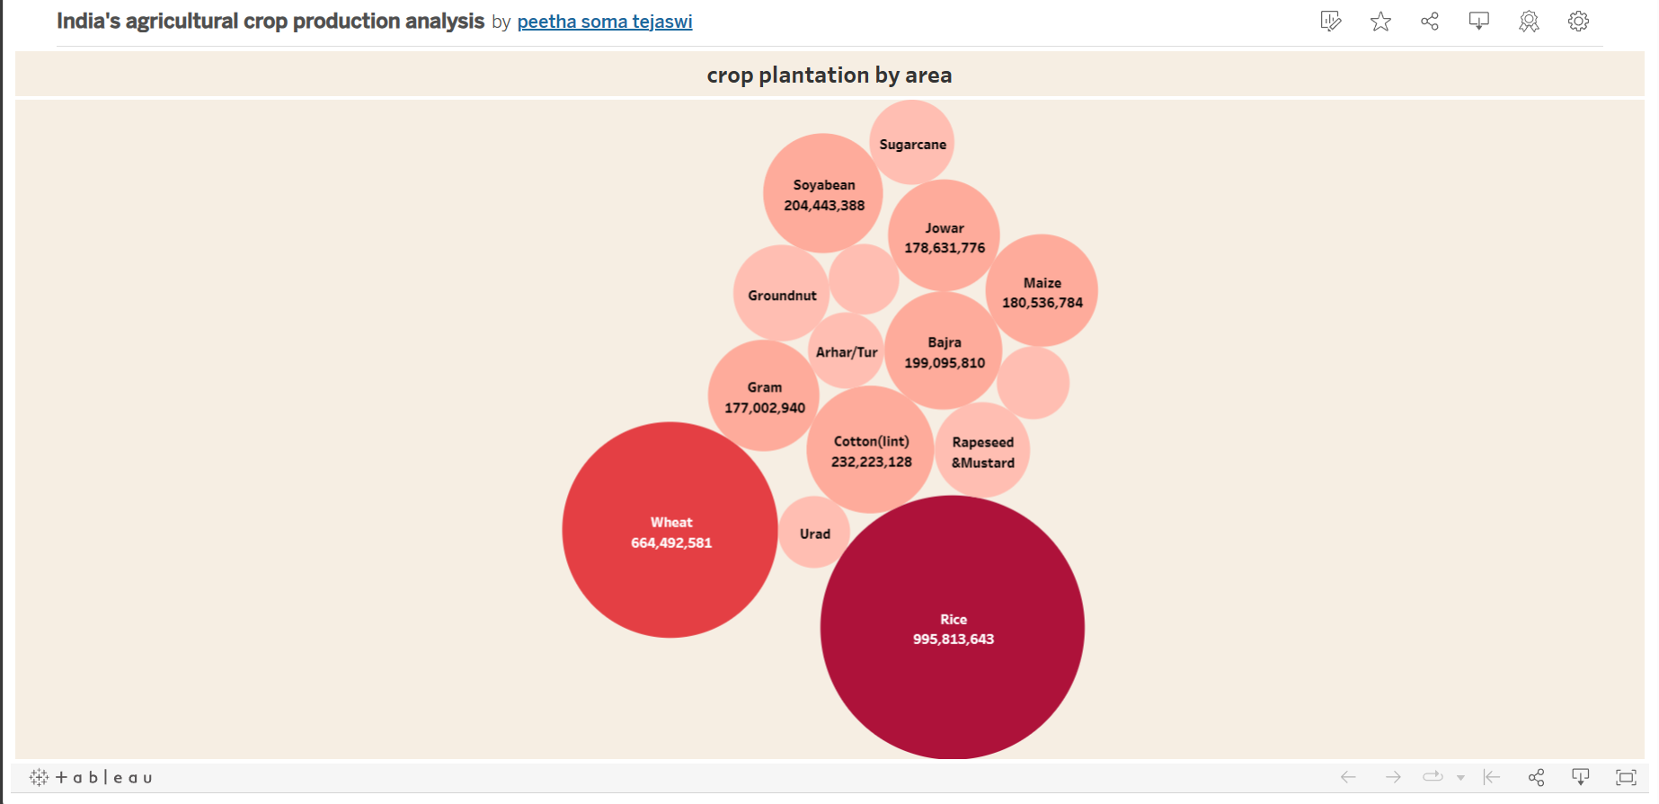

<div class='tableauPlaceholder' id='viz1699282703488' style='position: relative'><noscript><a href='#'><img alt='major crops growth yoy ' src='https:&#47;&#47;public.tableau.com&#47;static&#47;images&#47;In&#47;Indiasagriculturalcropproductionanalysis_16992665832770&#47;Sheet6&#47;1_rss.png' style='border: none' /></a></noscript><object class='tableauViz' style='display:none;'><param name='host_url' value='https%3A%2F%2Fpublic.tableau.com%2F' /> <param name='embed_code_version' value='3' /> <param name='site_root' value='' /><param name='name' value='Indiasagriculturalcropproductionanalysis_16992665832770&#47;Sheet6' /><param name='tabs' value='no' /><param name='toolbar' value='yes' /><param name='static_image' value='https:&#47;&#47;public.tableau.com&#47;static&#47;images&#47;In&#47;Indiasagriculturalcropproductionanalysis_16992665832770&#47;Sheet6&#47;1.png' /> <param name='animate_transition' value='yes' /><param name='display_static_image' value='yes' /><param name='display_spinner' value='yes' /><param name='display_overlay' value='yes' /><param name='display_count' value='yes' /><param name='language' value='en-US' /><param name='filter' value='publish=yes' /></object></div> <script type='text/javascript'> var divElement = document.getElementById('viz1699282703488'); var vizElement = divElement.getElementsByTagName('object')[0]; vizElement.style.width='100%';vizElement.style.height=(divElement.offsetWidth*0.75)+'px'; var scriptElement = document.createElement('script'); scriptElement.src = 'https://public.tableau.com/javascripts/api/viz_v1.js'; vizElement.parentNode.insertBefore(scriptElement, vizElement); </script>

<https://public.tableau.com/views/Indiasagriculturalcropproductionanalysis_16992665832770/Sheet6?:language=en-US&publish=yes&:display_count=n&:origin=viz_share_link>

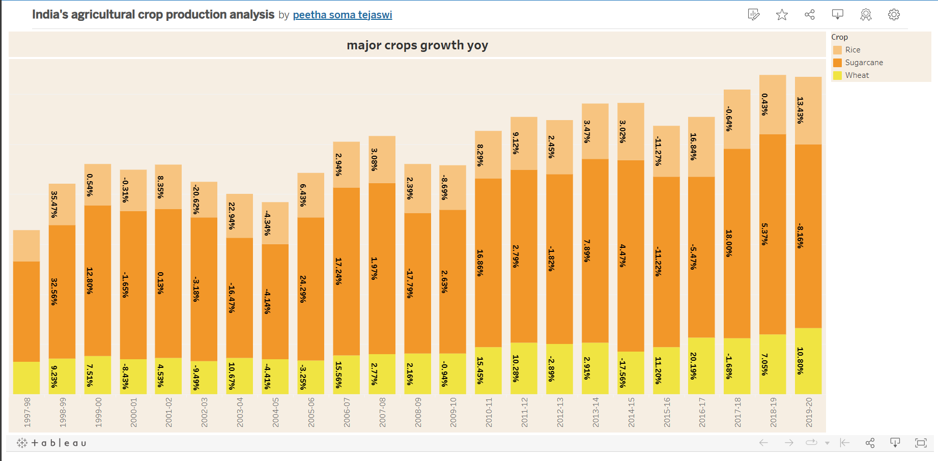

<div class='tableauPlaceholder' id='viz1699282800957' style='position: relative'><noscript><a href='#'><img alt='crops(plantation by count) ' src='https:&#47;&#47;public.tableau.com&#47;static&#47;images&#47;In&#47;Indiasagriculturalcropproductionanalysis_16992665832770&#47;Sheet7&#47;1_rss.png' style='border: none' /></a></noscript><object class='tableauViz' style='display:none;'><param name='host_url' value='https%3A%2F%2Fpublic.tableau.com%2F' /> <param name='embed_code_version' value='3' /> <param name='site_root' value='' /><param name='name' value='Indiasagriculturalcropproductionanalysis_16992665832770&#47;Sheet7' /><param name='tabs' value='no' /><param name='toolbar' value='yes' /><param name='static_image' value='https:&#47;&#47;public.tableau.com&#47;static&#47;images&#47;In&#47;Indiasagriculturalcropproductionanalysis_16992665832770&#47;Sheet7&#47;1.png' /> <param name='animate_transition' value='yes' /><param name='display_static_image' value='yes' /><param name='display_spinner' value='yes' /><param name='display_overlay' value='yes' /><param name='display_count' value='yes' /><param name='language' value='en-US' /><param name='filter' value='publish=yes' /></object></div> <script type='text/javascript'> var divElement = document.getElementById('viz1699282800957'); var vizElement = divElement.getElementsByTagName('object')[0]; vizElement.style.width='100%';vizElement.style.height=(divElement.offsetWidth*0.75)+'px'; var scriptElement = document.createElement('script'); scriptElement.src = 'https://public.tableau.com/javascripts/api/viz_v1.js'; vizElement.parentNode.insertBefore(scriptElement, vizElement); </script>

<https://public.tableau.com/views/Indiasagriculturalcropproductionanalysis_16992665832770/Sheet7?:language=en-US&publish=yes&:display_count=n&:origin=viz_share_link>

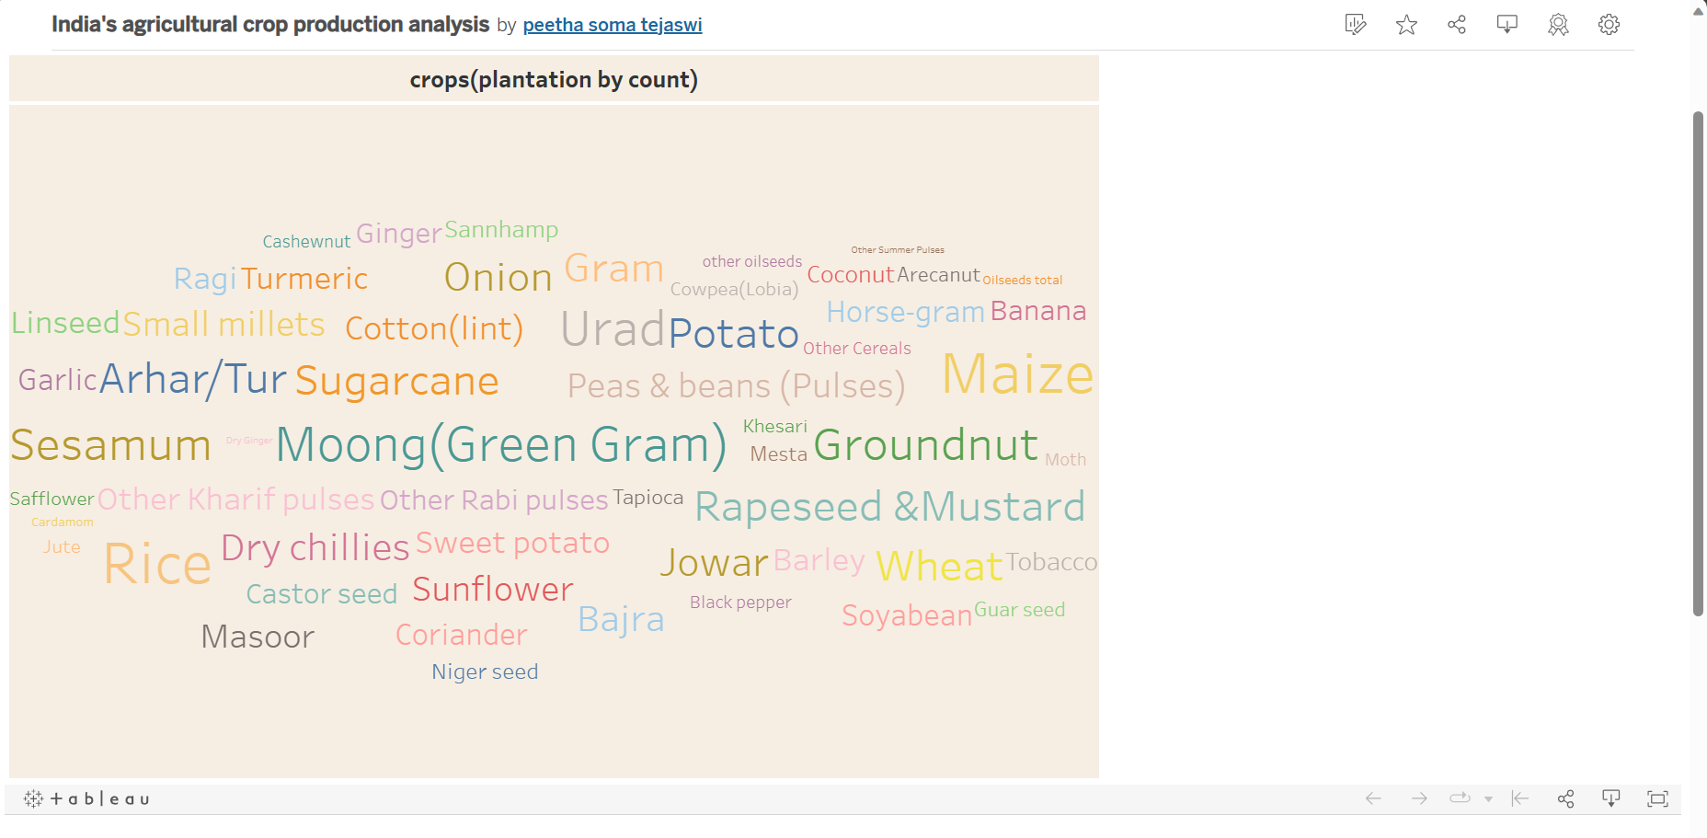

<div class='tableauPlaceholder' id='viz1699282905664' style='position: relative'><noscript><a href='#'><img alt='season wise production ' src='https:&#47;&#47;public.tableau.com&#47;static&#47;images&#47;In&#47;Indiasagriculturalcropproductionanalysis_16992665832770&#47;Sheet8&#47;1_rss.png' style='border: none' /></a></noscript><object class='tableauViz' style='display:none;'><param name='host_url' value='https%3A%2F%2Fpublic.tableau.com%2F' /> <param name='embed_code_version' value='3' /> <param name='site_root' value='' /><param name='name' value='Indiasagriculturalcropproductionanalysis_16992665832770&#47;Sheet8' /><param name='tabs' value='no' /><param name='toolbar' value='yes' /><param name='static_image' value='https:&#47;&#47;public.tableau.com&#47;static&#47;images&#47;In&#47;Indiasagriculturalcropproductionanalysis_16992665832770&#47;Sheet8&#47;1.png' /> <param name='animate_transition' value='yes' /><param name='display_static_image' value='yes' /><param name='display_spinner' value='yes' /><param name='display_overlay' value='yes' /><param name='display_count' value='yes' /><param name='language' value='en-US' /><param name='filter' value='publish=yes' /></object></div> <script type='text/javascript'> var divElement = document.getElementById('viz1699282905664'); var vizElement = divElement.getElementsByTagName('object')[0]; vizElement.style.width='100%';vizElement.style.height=(divElement.offsetWidth*0.75)+'px'; var scriptElement = document.createElement('script'); scriptElement.src = 'https://public.tableau.com/javascripts/api/viz_v1.js'; vizElement.parentNode.insertBefore(scriptElement, vizElement); </script>

<https://public.tableau.com/views/Indiasagriculturalcropproductionanalysis_16992665832770/Sheet8?:language=en-US&publish=yes&:display_count=n&:origin=viz_share_link>

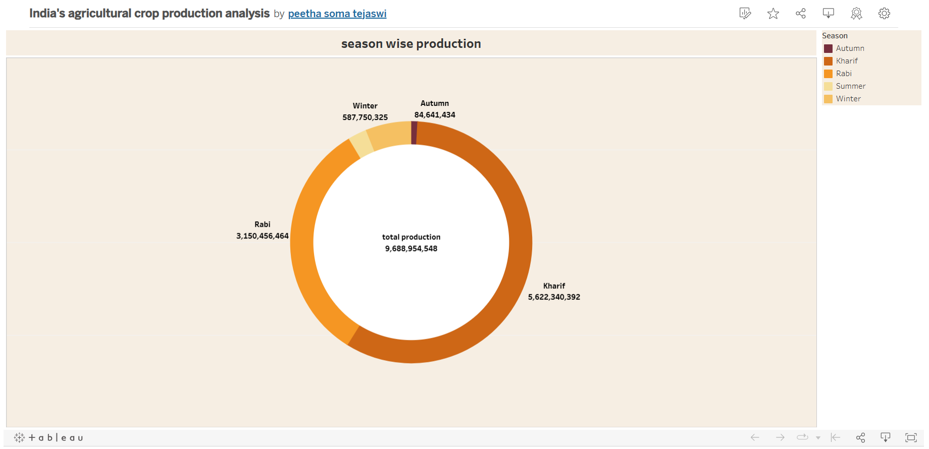

<div class='tableauPlaceholder' id='viz1699283013445' style='position: relative'><noscript><a href='#'><img alt='all regions ' src='https:&#47;&#47;public.tableau.com&#47;static&#47;images&#47;In&#47;Indiasagriculturalcropproductionanalysis_16992665832770&#47;Sheet9&#47;1_rss.png' style='border: none' /></a></noscript><object class='tableauViz' style='display:none;'><param name='host_url' value='https%3A%2F%2Fpublic.tableau.com%2F' /> <param name='embed_code_version' value='3' /> <param name='site_root' value='' /><param name='name' value='Indiasagriculturalcropproductionanalysis_16992665832770&#47;Sheet9' /><param name='tabs' value='no' /><param name='toolbar' value='yes' /><param name='static_image' value='https:&#47;&#47;public.tableau.com&#47;static&#47;images&#47;In&#47;Indiasagriculturalcropproductionanalysis_16992665832770&#47;Sheet9&#47;1.png' /> <param name='animate_transition' value='yes' /><param name='display_static_image' value='yes' /><param name='display_spinner' value='yes' /><param name='display_overlay' value='yes' /><param name='display_count' value='yes' /><param name='language' value='en-US' /><param name='filter' value='publish=yes' /></object></div> <script type='text/javascript'> var divElement = document.getElementById('viz1699283013445'); var vizElement = divElement.getElementsByTagName('object')[0]; vizElement.style.width='100%';vizElement.style.height=(divElement.offsetWidth*0.75)+'px'; var scriptElement = document.createElement('script'); scriptElement.src = 'https://public.tableau.com/javascripts/api/viz_v1.js'; vizElement.parentNode.insertBefore(scriptElement, vizElement); </script>

<https://public.tableau.com/views/Indiasagriculturalcropproductionanalysis_16992665832770/Sheet9?:language=en-US&publish=yes&:display_count=n&:origin=viz_share_link>

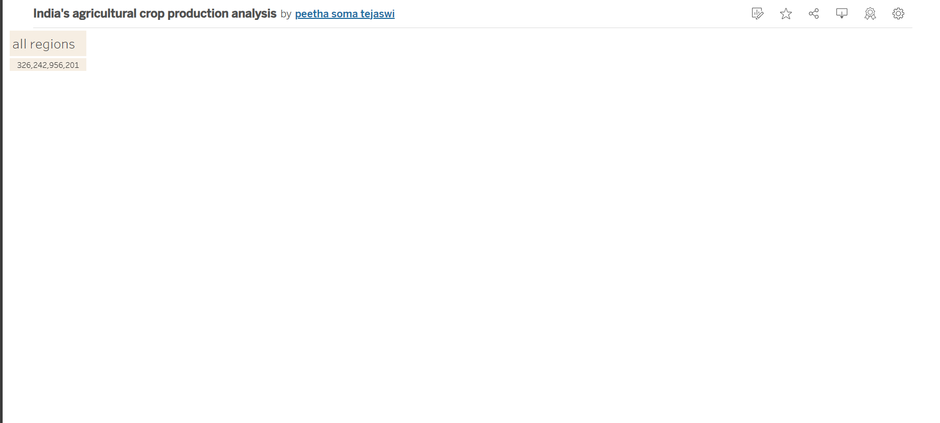

<div class='tableauPlaceholder' id='viz1699283187644' style='position: relative'><noscript><a href='#'><img alt='area in acres ' src='https:&#47;&#47;public.tableau.com&#47;static&#47;images&#47;KP&#47;KP98WXD5D&#47;1_rss.png' style='border: none' /></a></noscript><object class='tableauViz' style='display:none;'><param name='host_url' value='https%3A%2F%2Fpublic.tableau.com%2F' /> <param name='embed_code_version' value='3' /> <param name='path' value='shared&#47;KP98WXD5D' /> <param name='toolbar' value='yes' /><param name='static_image' value='https:&#47;&#47;public.tableau.com&#47;static&#47;images&#47;KP&#47;KP98WXD5D&#47;1.png' /> <param name='animate_transition' value='yes' /><param name='display_static_image' value='yes' /><param name='display_spinner' value='yes' /><param name='display_overlay' value='yes' /><param name='display_count' value='yes' /><param name='language' value='en-US' /><param name='filter' value='publish=yes' /></object></div> <script type='text/javascript'> var divElement = document.getElementById('viz1699283187644'); var vizElement = divElement.getElementsByTagName('object')[0]; if ( divElement.offsetWidth > 800 ) { vizElement.style.width='1000px';vizElement.style.height='827px';} else if ( divElement.offsetWidth > 500 ) { vizElement.style.width='1000px';vizElement.style.height='827px';} else { vizElement.style.width='100%';vizElement.style.height='827px';} var scriptElement = document.createElement('script'); scriptElement.src = 'https://public.tableau.com/javascripts/api/viz_v1.js'; vizElement.parentNode.insertBefore(scriptElement, vizElement); </script>

<https://public.tableau.com/shared/KP98WXD5D?:display_count=n&:origin=viz_share_link>

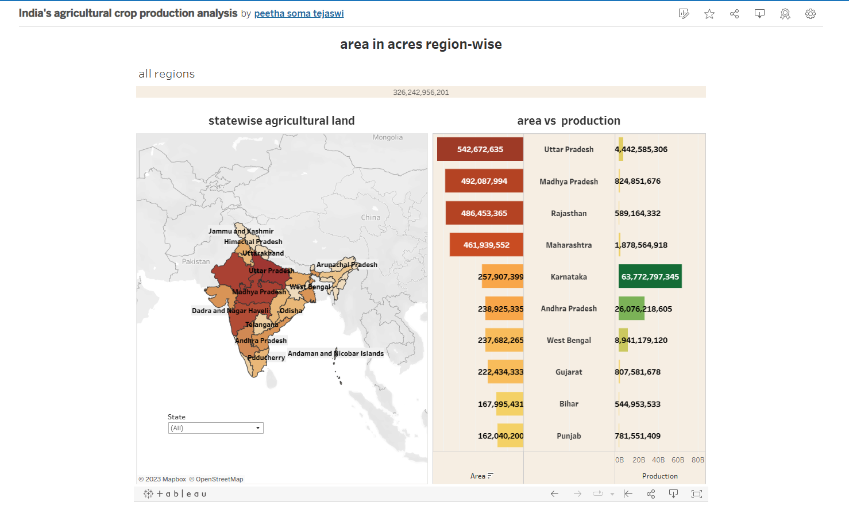

<div class='tableauPlaceholder' id='viz1699283291853' style='position: relative'><noscript><a href='#'><img alt='production in tonnes ' src='https:&#47;&#47;public.tableau.com&#47;static&#47;images&#47;In&#47;Indiasagriculturalcropproductionanalysis_16992665832770&#47;Dashboard2&#47;1_rss.png' style='border: none' /></a></noscript><object class='tableauViz' style='display:none;'><param name='host_url' value='https%3A%2F%2Fpublic.tableau.com%2F' /> <param name='embed_code_version' value='3' /> <param name='site_root' value='' /><param name='name' value='Indiasagriculturalcropproductionanalysis_16992665832770&#47;Dashboard2' /><param name='tabs' value='no' /><param name='toolbar' value='yes' /><param name='static_image' value='https:&#47;&#47;public.tableau.com&#47;static&#47;images&#47;In&#47;Indiasagriculturalcropproductionanalysis_16992665832770&#47;Dashboard2&#47;1.png' /> <param name='animate_transition' value='yes' /><param name='display_static_image' value='yes' /><param name='display_spinner' value='yes' /><param name='display_overlay' value='yes' /><param name='display_count' value='yes' /><param name='language' value='en-US' /><param name='filter' value='publish=yes' /></object></div> <script type='text/javascript'> var divElement = document.getElementById('viz1699283291853'); var vizElement = divElement.getElementsByTagName('object')[0]; if ( divElement.offsetWidth > 800 ) { vizElement.style.width='1000px';vizElement.style.height='827px';} else if ( divElement.offsetWidth > 500 ) { vizElement.style.width='1000px';vizElement.style.height='827px';} else { vizElement.style.width='100%';vizElement.style.height='1027px';} var scriptElement = document.createElement('script'); scriptElement.src = 'https://public.tableau.com/javascripts/api/viz_v1.js'; vizElement.parentNode.insertBefore(scriptElement, vizElement); </script>

<https://public.tableau.com/views/Indiasagriculturalcropproductionanalysis_16992665832770/Dashboard2?:language=en-US&publish=yes&:display_count=n&:origin=viz_share_link>

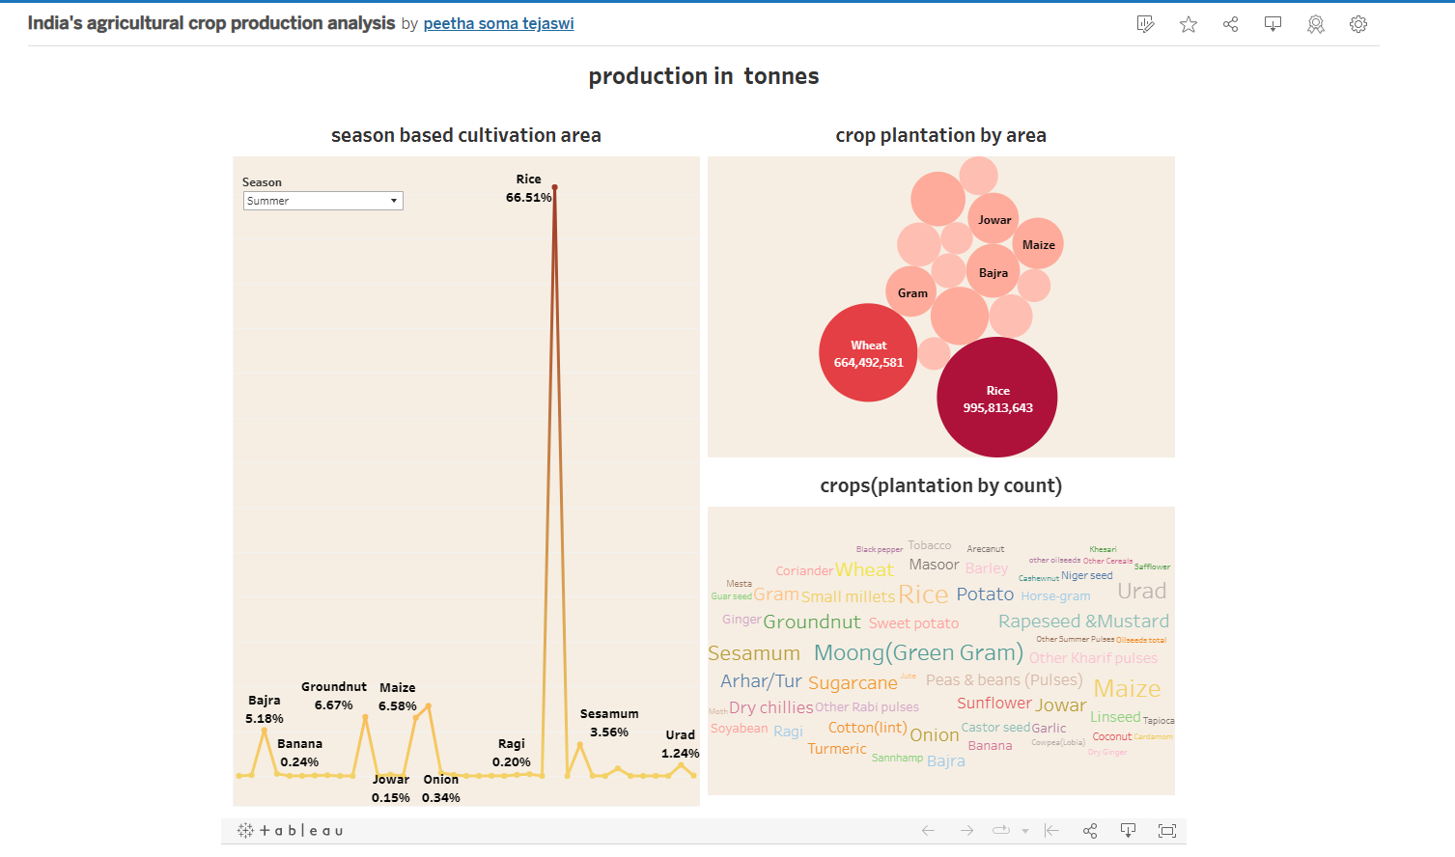

<div class='tableauPlaceholder' id='viz1699283381436' style='position: relative'><noscript><a href='#'><img alt='Dashboard 3 ' src='https:&#47;&#47;public.tableau.com&#47;static&#47;images&#47;In&#47;Indiasagriculturalcropproductionanalysis_16992665832770&#47;Dashboard3&#47;1_rss.png' style='border: none' /></a></noscript><object class='tableauViz' style='display:none;'><param name='host_url' value='https%3A%2F%2Fpublic.tableau.com%2F' /> <param name='embed_code_version' value='3' /> <param name='site_root' value='' /><param name='name' value='Indiasagriculturalcropproductionanalysis_16992665832770&#47;Dashboard3' /><param name='tabs' value='no' /><param name='toolbar' value='yes' /><param name='static_image' value='https:&#47;&#47;public.tableau.com&#47;static&#47;images&#47;In&#47;Indiasagriculturalcropproductionanalysis_16992665832770&#47;Dashboard3&#47;1.png' /> <param name='animate_transition' value='yes' /><param name='display_static_image' value='yes' /><param name='display_spinner' value='yes' /><param name='display_overlay' value='yes' /><param name='display_count' value='yes' /><param name='language' value='en-US' /><param name='filter' value='publish=yes' /></object></div> <script type='text/javascript'> var divElement = document.getElementById('viz1699283381436'); var vizElement = divElement.getElementsByTagName('object')[0]; if ( divElement.offsetWidth > 800 ) { vizElement.style.width='100%';vizElement.style.height=(divElement.offsetWidth*0.75)+'px';} else if ( divElement.offsetWidth > 500 ) { vizElement.style.width='100%';vizElement.style.height=(divElement.offsetWidth*0.75)+'px';} else { vizElement.style.width='100%';vizElement.style.height='1027px';} var scriptElement = document.createElement('script'); scriptElement.src = 'https://public.tableau.com/javascripts/api/viz_v1.js'; vizElement.parentNode.insertBefore(scriptElement, vizElement); </script>

<https://public.tableau.com/views/Indiasagriculturalcropproductionanalysis_16992665832770/Dashboard3?:language=en-US&publish=yes&:display_count=n&:origin=viz_share_link>

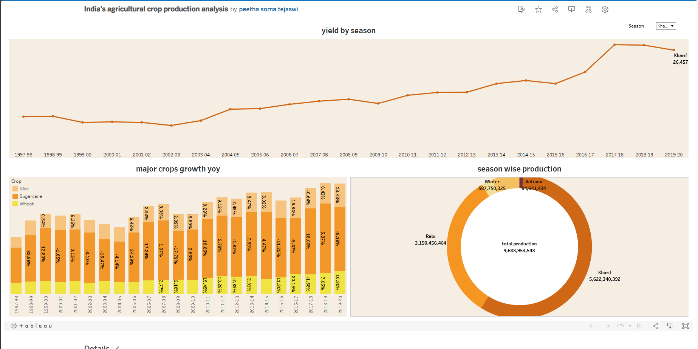

<div class='tableauPlaceholder' id='viz1699283469999' style='position: relative'><noscript><a href='#'><img alt='insights into India&#39;s agricultural cultivation ' src='https:&#47;&#47;public.tableau.com&#47;static&#47;images&#47;In&#47;Indiasagriculturalcropproductionanalysis_16992665832770&#47;Story1&#47;1_rss.png' style='border: none' /></a></noscript><object class='tableauViz' style='display:none;'><param name='host_url' value='https%3A%2F%2Fpublic.tableau.com%2F' /> <param name='embed_code_version' value='3' /> <param name='site_root' value='' /><param name='name' value='Indiasagriculturalcropproductionanalysis_16992665832770&#47;Story1' /><param name='tabs' value='no' /><param name='toolbar' value='yes' /><param name='static_image' value='https:&#47;&#47;public.tableau.com&#47;static&#47;images&#47;In&#47;Indiasagriculturalcropproductionanalysis_16992665832770&#47;Story1&#47;1.png' /> <param name='animate_transition' value='yes' /><param name='display_static_image' value='yes' /><param name='display_spinner' value='yes' /><param name='display_overlay' value='yes' /><param name='display_count' value='yes' /><param name='language' value='en-US' /><param name='filter' value='publish=yes' /></object></div> <script type='text/javascript'> var divElement = document.getElementById('viz1699283469999'); var vizElement = divElement.getElementsByTagName('object')[0]; vizElement.style.width='100%';vizElement.style.height=(divElement.offsetWidth*0.75)+'px'; var scriptElement = document.createElement('script'); scriptElement.src = 'https://public.tableau.com/javascripts/api/viz_v1.js'; vizElement.parentNode.insertBefore(scriptElement, vizElement); </script>

<https://public.tableau.com/views/Indiasagriculturalcropproductionanalysis_16992665832770/Story1?:language=en-US&publish=yes&:display_count=n&:origin=viz_share_link>

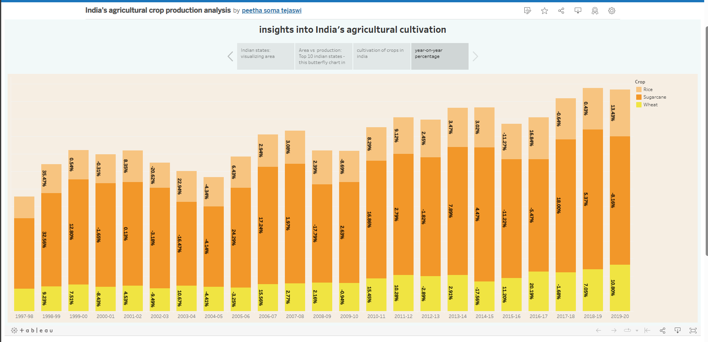

<https://public.tableau.com/views/Indiasagriculturalcropproductionanalysis_16992665832770/Story2?:language=en-US&publish=yes&:display_count=n&:origin=viz_share_link>

<div class='tableauPlaceholder' id='viz1699281810727' style='position: relative'><noscript><a href='#'><img alt='Insights into India&#39;s agricultural cultivation ' src='https:&#47;&#47;public.tableau.com&#47;static&#47;images&#47;In&#47;Indiasagriculturalcropproductionanalysis_16992665832770&#47;Story2&#47;1_rss.png' style='border: none' /></a></noscript><object class='tableauViz' style='display:none;'><param name='host_url' value='https%3A%2F%2Fpublic.tableau.com%2F' /> <param name='embed_code_version' value='3' /> <param name='site_root' value='' /><param name='name' value='Indiasagriculturalcropproductionanalysis_16992665832770&#47;Story2' /><param name='tabs' value='no' /><param name='toolbar' value='yes' /><param name='static_image' value='https:&#47;&#47;public.tableau.com&#47;static&#47;images&#47;In&#47;Indiasagriculturalcropproductionanalysis_16992665832770&#47;Story2&#47;1.png' /> <param name='animate_transition' value='yes' /><param name='display_static_image' value='yes' /><param name='display_spinner' value='yes' /><param name='display_overlay' value='yes' /><param name='display_count' value='yes' /><param name='language' value='en-US' /><param name='filter' value='publish=yes' /></object></div> <script type='text/javascript'> var divElement = document.getElementById('viz1699281810727'); var vizElement = divElement.getElementsByTagName('object')[0]; vizElement.style.width='1366px';vizElement.style.height='795px'; var scriptElement = document.createElement('script'); scriptElement.src = 'https://public.tableau.com/javascripts/api/viz_v1.js'; vizElement.parentNode.insertBefore(scriptElement, vizElement); </script>

